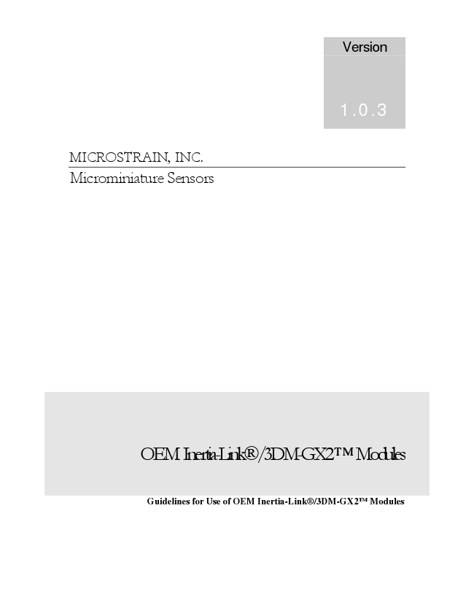
Version
1.0.3
MICROSTRAIN, INC. Microminiature Sensors
OEM Inertia-Link®/3DM-GX2 TM Modules
Guidelines for Use of OEM Inertia-Link®/3DM-GX2TM Modules
©2007 by MicroStrain, Inc. 310 Hurricane Lane, Suite 4 Williston, VT 05495 Phone 802-862-6629 Fax 802-863-4093 www.microstrain.com support@microstrain.com
REVISED: 22 October 2007
MicroStrain, Inc.
2
MicroStrain, Inc. Table of Contents
OVERVIEW ................................................................................................................................................. 4
PIN DESCRIPTIONS .................................................................................................................................. 4
PHYSICAL MOUNTING............................................................................................................................ 5
CONNECTIVITY ........................................................................................................................................ 7
POWER......................................................................................................................................................... 8
COMMUNICATIONS ................................................................................................................................. 8
ENVIRONMENTAL.................................................................................................................................... 8
MAGNETIC INTERFERENCE ................................................................................................................. 8
STANDARD IMPLEMENTATION........................................................................................................... 8
CUSTOM CAPABILITIES......................................................................................................................... 9
AVAILABLE NON-STANDARD FEATURES......................................................................................... 9
3
MicroStrain, Inc.
Overview The Inertia-Link® and 3DM-GX2TM sensors can be provided as OEM modules for tight integration into a customer’s system. Each module simply consists of the sensor circuit board with mounting standoffs. No communications interface, enclosure or cable is provided. The module can be mounted as a component on a customer designed circuit board. Power and communications is established through a surface mount connector. This document provides the information needed to utilize the OEM module in this manner.
Pin Descriptions Bold indicates required connection. All others may be left unconnected. Pins identified as “unimplemented” correspond to functions that are not available in the standard module firmware. Consult the factory for options on activating these functions.
Pin Name Type Function
1 NC No Connect 2 NC No Connect 3 NC No Connect 4 Vdd P Power Supply. 5.2 – 9.0V (5.5 recommended) 5 NC No Connect 6 Sout O SPI data out (unimplemented) 7 Sclk I/O SPI clock (unimplemented) 8 Factory Must be tied to Ground on host PC board. 9 PPS I/O Timer Reset (1PPS) 10 GPIO1 I/O General Purpose I/O pin (unimplemented) 11 ModClk O Modulator Clock driving A/D converters. A/D conversion
occurs every 384 ModClk’s. 12 GPIO2 I/O General Purpose I/O pin (unimplemented) 13 Tx
Status
4 O Output - Normally high. Low during transmission of data
to host. 14 GND G Ground 15 NC No Connect 16 NC No Connect 17 Sin I SPI data in (unimplemented) 18 Tx O UART transmit (3.3V) 19 Rx I UART receive (3.3V) 20 NC No Connect
Table 1. Pin Assignments for Primary 20 pin connector
Physical Mounting The OEM module must be physically fastened to a host circuit board. This is accomplished with four #0-80 screws which pass through holes in the host PC board, and screw into the OEM module’s standoffs. Care should be taken to ensure that the OEM module is not exposed to bending or twisting loads which may deform it and compromise its calibration accuracy. The host PC board should be well supported mechanically in the area of the OEM module to avoid exposing the module to vibration or shock loading. High vibration degrades the performance of all inertial measurement systems including the Inertia-Link®/3DM-GX2TM.
MicroStrain, Inc.
Figure 1. Host PC board layout requirements. All dimensions in inches. The connector part number is Hirose DF15(1.8)-20DS-0.65V(56). This part is available from Digikey (part number H10429CT).
5
TO
1.255 1.400
Figure 2. Illustration showing mounting of Inertia-Link OEM module to Host PC board. (Dimensions in inches.)
Y
Z
Y X
Z
Z
Y
X
X
HOST PCB
0.465
MicroStrain, Inc.
6
MicroStrain, Inc.
HOST PCB
Y
Z
X
1.420
1.260 Z
Z
0.759
Y
X
Y
X
Figure 3. Illustration showing mounting of 3DM-GX2 OEM module to Host PC board. (Dimensions in inches.)
Connectivity Power and communications is provided through a 20 pin surface mount connector. The mating connector is Hirose part number DF15(1.8)-20DS-0.65V(56) (Digikey part number H10429CT). This must be integrated into the host PC board.
7
MicroStrain, Inc.
Power The OEM module must be powered by a DC supply with voltage between 5.2V and 9.0V. 5.5V is recommended. Higher voltage will result in higher power dissipation. A 5.0V supply is not sufficient, and if used, will lead to inadequate system performance. The OEM module has on-board regulators which provide internal power rails of 5.0V and 3.3V. The host PC board does not have direct access to these rails.
Communications A serial UART is used to communicate data to and from the host. The standard baud rate is 115200 bps. No transceiver is present. The Tx and Rx lines are 3.3V logic level. They can directly drive Rx and Tx lines of a 3.3V processor on the host system. The OEM module’s Rx line is NOT 5V tolerant. Consult the factory if 5V tolerance is required.
Environmental Although the Inertia-Link® and 3DM-GX2TM modules are fully temperature compensated, the modules should still be protected from strong air currents, and large point sources of heat. These can induce thermal gradients across the OEM modules which will compromise their performance. If high velocity cooling fans are used in the host system, the OEM module should be protected by the use of a shield, or by locating it outside of the direct air stream.
Magnetic Interference The 3DM-GX2TM differs from the Inertia-Link® in that it includes a magnetometer to sense Earth’s geomagnetic field. The performance of this sensor can be compromised by the presence of ferromagnetic materials, or magnets in the immediate vicinity. Care should be taken to understand what the potential sources of such interference are, and to minimize them. Stainless steel (18-8 or 300 series), brass or aluminum hardware is recommended. Sources of interference that cannot be completely eliminated should be placed as far away from the magnetometer as possible.
Standard Implementation In most applications, the only pins that need to be implemented are power and ground (4 and 14) and UART Tx and Rx (18 and 19). In addition, pin 8 must be tied to ground. These will provide power to the sensor, and UART communications between the sensor and host. No other functions are typically required. All other pins can be left unconnected. Once the module is powered up, it is immediately ready to operate and communicate to the host. Refer to the Data Communications Protocol manual for information on how to communicate with the device.
Timer Reset pin (1 pulse per second input) Pin 9 of the 20 pin connector is configured as a digital input (0-3.3V). Whenever a rising edge is detected on this pin, the on-board timer will be reset to zero. Subsequent
8
MicroStrain, Inc.
datarecords will then have a timestamp which reflects the elapsed time since the most recent rising edge event. This feature can be used as a means of synchronizing the on- board timer with the 1 pulse per second digital output of a GPS receiver.
Pin 9 has a weak (25kOhm) pullup to the 3.3V power rail. It also has a 1000 ohm series resistor as a protection measure.
Custom Capabilities A number of features have been incorporated in the Inertia-Link®/3DM-GX2TM hardware which are intended to provide flexibility in the event that a customer application requires customization. These features are not implemented in the standard firmware. Utilizing them requires that custom firmware be written and implemented. Consult the factory for additional details if any of these features are needed.
Available Non-standard Features 1. SPI communications: Pins 6, 7 and 17 can be configured to establish SPI communications to the host system as an alternative to the UART.
2. GPIO pins: Two general purpose digital Input/Output pins are available. These can be programmed as necessary to provide additional information flow between the host and the Inertia-Link®/3DM-GX2TM module. For example, a pulse could be driven to a GPIO pin coinciding with every A/D converter read. This could then be used by the host for synchronization of other input devices.
3. Modulator clock: The OEM module’s Sigma-Delta A/D converters must be supplied with a modulator clock. A data conversion is completed once for every 384 clock cycles. Normally, this clock is provided by the onboard processor, and is therefore inherently tied to the timing of the on-board crystal. In some applications it may be necessary to achieve tight synchronization between the A/D conversions, and some other process being performed by the host system. In that case, it is possible for the host system to provide the modulator clock for the A/D converters. The ModClk pin (11) would then be configured as an input (rather than an output as is the default), and the host would supply the modulator clock. An A/D conversion would occur every 384 clock cycles.
Auxiliary Connector An auxiliary connector is available which can be used to access several additional features of the Inertia-Link. To access these features, the customer should place a 10 pin female receptacle (Mill-Max part number 851-XX-010-30-00100) on the host PC board as shown in Figure 4. Also, the factory should be instructed to populate the mating male connector on the Inertia-Link/3DM-GX2.
9
MicroStrain, Inc.
0.050
0.030
0.135
1
0.060
2 3
4 5
6 7
8 9
10
0.787
0.560
Figure 4. Host PC board layout requirements for auxiliary connector. All dimensions in inches. The connector part number is Mill-Max 851-XX-010-30-00100.
Pin Name Type Function
1 TxAux/SDO O Auxiliary UART Tx (3.3V) or
SPI Data Out 2 RxAux/SDI I Auxiliary UART Rx (3.3V) or
SPI Data In 3 GPIO1/SCK1 I/O General Purpose I/O or
SPI Clock 4 GPIO2/SPI_SEL I/O General Purpose I/O or
SPI Chip Select 5 Vout O Regulated 3.3V Supply Output (to power
peripheral devices). 25mA max. 6 GND Gnd System Ground 7 Vin5.5 Supply Supply Voltage, 5.5V minimum* 8 Vin3.5 Supply Supply Voltage, 3.5V minimum* 9 Tx O Primary UART Tx (same as pin 18 on 20 pin
connector). 10 Rx I Primary UART Rx (same as pin 19 on 20 pin
connector).
Table 2. Pin Assignments for Auxiliary 10 pin connector *
Pins 7 and 8 may be tied together on Inertia-Link PCboard. Consult factory.
10
O

